Raft Logo:

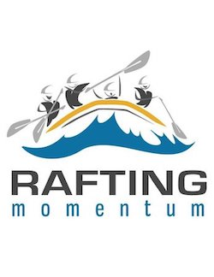

Primary color: #335c67

Secondary color:#fff3b0

Accent1 color: #e09f3e

Accent2 color: #9e2a2b

Accent3 color: #540b0e

Palette link: [Palette - Coolors](https://coolors.co/palette/335c67-fff3b0-e09f3e-9e2a2b-540b0e)

Heading font: Roboto Mono

Text font: Nunito